|  |  |
| --- | --- |
| \\VFILERDPI\DPI-Home\OBRIENR2\My Documents\Downloads\PP logo.jpg |  |
| **COUNCIL ASSESSMENT REPORT**  HUNTER AND CENTRAL COAST REGIONAL PLANNING PANEL | |

|  |  |
| --- | --- |
| **PANEL REFERENCE and DA NUMBER** | PPSHCC-35 - DA/2238/2017 |
| **PROPOSAL** | Subdivision  Subdivision of two lots into 210 residential lots, associated infrastructure and heritage walkway. |
| **ADDRESS** | Lots 1, 2, 3 and 4 DP 1180181  1A, 2B, 41 and 69A Flowers Drive, Catherine Hill Bay |
| **APPLICANT** | Monteath and Powys Pty Ltd |
| **OWNER** | Wallalong Land Development Pty Ltd |
| **DA LODGEMENT DATE** | 24 November 2017 |
| **APPLICATION TYPE** | Development Application |
| **REGIONALLY SIGNIFICANT CRITERIA** | Clause 20 of SRD SEPP and Schedule 4A of EP&A Act – General development over $20 million (cl.3) and coastal subdivision (cl.9). |
| **CIV** | $46,740,000 |
| **CLAUSE 4.6 REQUESTS** | Nil |
| **KEY SEPP/LEP** | Concept Plan MP10_0089 – Middle Camp Residential Development (Southern Estates) |
| **TOTAL & UNIQUE SUBMISSIONS KEY ISSUES IN SUBMISSIONS** | Four submissions in objection were received during the first notification period.  No submissions were received during the second and third notification periods.  The key issues raised in the submissions were:   * increased traffic in Catherine Hill Bay village * traffic safety at intersection of Flowers Drive and Pacific Highway * stormwater management * ecology impacts due to clearing * utility provision * European and Aboriginal Heritage * confirmation of the Statement of Commitments * visual impacts. |
| **DOCUMENTS SUBMITTED FOR CONSIDERATION** | **Attachments**  * Attachment A: Draft conditions of consent * Attachment B: Concept Approval compliance table * Attachment C: Urban Design Guidelines compliance table |
| **SPECIAL INFRASTRUCTURE CONTRIBUTIONS (S7.24)** | Condition 1.14 of the Concept Approval requires state infrastructure contributions. Documentation confirming satisfactory arrangements have been obtained has been submitted on 1 April 2020. |
| **RECOMMENDATION** | Approval, following resolution of outstanding matters |
| **DRAFT CONDITIONS TO APPLICANT** | Yes |
| **SCHEDULED MEETING DATE** | 13 October 2021 |
| **PREPARED BY** | David Pavitt, Chief Development Engineer |
| **DATE OF REPORT** | 6 October 2021 |

**EXECUTIVE SUMMARY**

The development application (DA/2238/2017) seeks consent for the development of a 210 residential subdivision, with associated infrastructure and heritage walkway.

The development is permitted under Concept Plan MP10_0089 which was approved in 2012 for residential development of up to 222 lots, dedication of conservation land comprising approximately 526 hectares, and associated infrastructure.

The site is known as 1A, 2B, 41 and 69A Flowers Drive, Catherine Hill Bay (‘the site’) and comprises 42.7 hectares of land.

The planning controls relevant to the proposal include *State Environmental Planning Policy (State and Regional Development) 2011, State Environmental Planning Policy (Infrastructure) 2007, State Environmental Planning Policy 44 - Koala Habitat Protection, State Environmental Planning Policy No. 55 – Remediation of land and State Environmental Planning Policy 71 - Coastal Protection.*

The proposal is consistent with various provisions of the planning controls including:

* clause 104(3) traffic-generating development of *State Environmental Planning Policy (Infrastructure) 2007* for subdivision of 200 of more residential lots
* *State Environmental Planning Policy 44 - Koala Habitat Protection* as the land is not core koala habitat
* matters for consideration under *State Environmental Planning Policy 71 – Coastal Protection.*

The proposal is non consistent with various provisions of the planning controls including:

* Clause 7 of *State Environmental Planning Policy No 55—Remediation of Land* as it has not yet been established whether the land is suitable for its intended use.
* Clause 45 of *State Environmental Planning Policy (Infrastructure) 2007* requiring 21 days’ notice be provided to Ausgrid.

The application must also be consistent with the Concept Approval. The proposal is consistent with the Concept Approval, with the exception of the following:

* Endorsement from Office of Environment and Heritage regarding management of the interface between the development area and the adjacent National Park
* Outcome of Workshop Building retention or demolition
* Extent of earthworks, ground water impacts and impacts to retention of heritage structures
* Remediation of contamination
* Detailed design for heritage pathway
* Landscaping details for Workshop Park and Lemon Tree Park.

The development is not integrated development or development requiring concurrence as the terms of the Concept Approval apply. In accordance with the Concept Approval, the application was referred to Department of Planning, Industry and Environment, Office of Environment and Heritage, Transport for NSW, NSW Rural Fire Service, Subsidence Advisory NSW. All agencies who have been referred to are satisfied with the proposed development. The Office of Environment and Heritage has not been consulted with regarding the management of the interface between the development area and the adjacent National Park.

All legislative requirements to enable granting of consent have been satisfied, with the exception of the following:

* Clause 7 of *State Environmental Planning Policy No 55—Remediation of Land* for consideration of whether the land is contaminated.
* Clause 45 of *State Environmental Planning Policy (Infrastructure) 2007* requiring 21 days’ notice be provided to Ausgrid.

The application was lodged 24 November 2017.

The application was placed on public exhibition from 30 November 2017 to 14 December 2017, with four submissions in objection received. These submissions identified concerns in relation to increased traffic in Catherine Hill Bay village, traffic safety at intersection of Flowers Drive and Pacific Highway, stormwater management, ecology impacts due to clearing, utility provision, and European and Aboriginal Heritage. These issues are considered further in this report.

A request for information was issued to the applicant in June 2018 regarding issues with water and sewer servicing of the site. This matter was resolved and responded to late in 2019.

Detailed assessment of the application was undertaken with additional and amended documentation submitted at various times from December 2019, February 2020 and March 2020.

Another request for information was issued in April 2020, with additional information submitted in June 2020 and November 2020.

The application is referred to the Hunter and Central Coast Regional Planning Panel (‘the Panel’) as the development is regionally significant development, pursuant to Clause 20 of State Environmental Planning Policy *(State and Regional Development) 2011* and Schedule 4A of the *Environmental Planning and Assessment Act 1979* as the proposal is development with a CIV over $20 million, and coastal subdivision.

Multiple briefings were held with the Panel on 3 June 2020, 9 September 2020, and 14 July 2021. Several key issues were discussed including background of concept approval, consistency of development with concept approval, statutory framework, servicing strategy and environmental impacts, and boundary conditions and potential impacts.

The key issues associated with the proposal include:

1. Concept Approval consistency
2. Contamination
3. Biodiversity offsets
4. Bushfire
5. Visual impact
6. Traffic impacts
7. Ecological impacts from servicing
8. Workshop Building retention or demolition
9. Workshop Park and Lemon Tree Parks
10. European heritage and heritage walkway
11. Stormwater management
12. Impacts to adjacent National Park

With the exception of the outstanding issues identified in this report including the proposal is recommended for approval. Details on the proposed resolution of the outstanding matters are included in the report.

Should the Panel not support resolution of the outstanding matters, the application must be refused. Refusal of the application would also result in the Concept Approval lapsing.

Following a detailed assessment of the proposal, DA/2238/2017 is recommended for approval, following resolution of the outstanding matters.

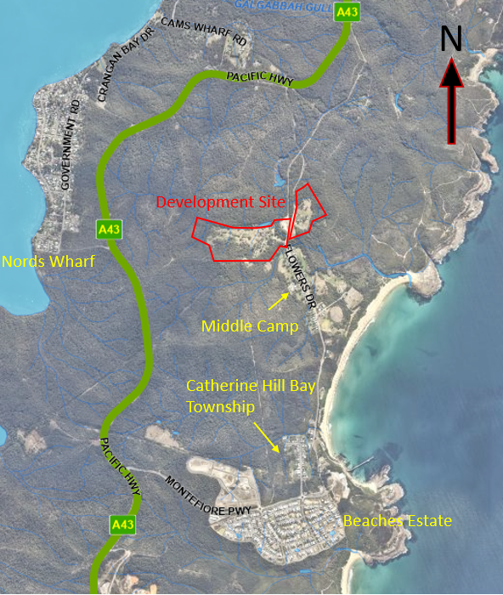

**Figure 1: Location plan**

1. **THE SITE AND LOCALITY**

**1.1 The locality**

The site is within Catherine Hill Bay, which is a suburb located on the coast in the south-east of the Lake Macquarie local government area.

Access to Catherine Hill Bay is from the Pacific Highway via Flowers Drive (northern access) and Montefiore Drive (southern access). The township is not serviced by reticulated water or sewer.

The town nestles in a natural amphitheatre with ridgelines to the north, south and west and the ocean directly to the east. Wallarah National Park is to the north of the town and provides separation from the suburb of Caves Beach. To the south is Munmorah State Conservation Area.

Catherine Hill Bay was developed as a result of coal mining operations adjacent to the township. The town traditionally consisted of approximately 100 modest former mining cottages in two villages known as Middle Camp in the north and Catherine Hill Bay township in the south. Middle Camp contains approximately 50 former mining cottages and is serviced primarily by Flowers Drive. The Catherine Hill Bay township is similarly modest in scale but contains other amenities such as a pub and surf life saving club.

Recently a residential subdivision known as “Beaches Estate” has been developed by the Rose Group to the south of the town, which is approximately 90% complete and will contain over 500 dwellings and a small retail precinct. The Rose Group development and the development proposed under the current development application were both major projects assessed by the state government.

**1.2 Site background**

The site forms part of Concept Plan MP10_0089 which was approved by the Planning Assessment Commission in 2012 for residential development of up to 222 lots over two hamlets, dedication of conservation land comprising approximately 526 hectares, and associated infrastructure.

The Concept Approval was to lapse after five years if no development application was lodged, however the Concept Approval was modified in July 2017 to obtain an extension of 12 months until July 2018. The current development application was lodged in November 2017 and as such the Concept Approval is still alive.

A development application for demolition of the Workshop Building in Hamlet B is currently being assessment by Council (DA/2246/2021). This application does not include subdivision, and therefore sits outside of, and does not benefit from the Concept Approval.

**1.3 The site**

The site is located north of the Middle Camp village. The residential portion of the site is divided into two distinct hamlets, Hamlet A and Hamlet B.

Hamlet A has an area of 7.3 hectares and is located on the eastern side of Flowers Drive. Hamlet B has an area of 20.88 hectares and is located to the west of Flowers Drive and is bordered to the north, west and south by National Park (refer to Figure 2).

Hamlet A was the location of a former sawmill that serviced the coal mining operations on Hamlet B. The land is cleared and is used primarily for grazing and contains a dwelling and outbuildings.

Hamlet B was the location for the main mining operations. The land has some regrowth but is generally cleared and is used primarily for grazing and contains several dwellings and outbuildings, and heritage items as a result of the former mining activities on the site. There are known shallow mine workings within this land.

The site also includes a heritage walkway that extends from Hamlet B to the east over Middle Camp Gully and then to the south along the former rail corridor (refer to Figure 2). This corridor includes land that has partly revegetated, cleared land associated with four dwellings within Middle Camp, and the former rail corridor.

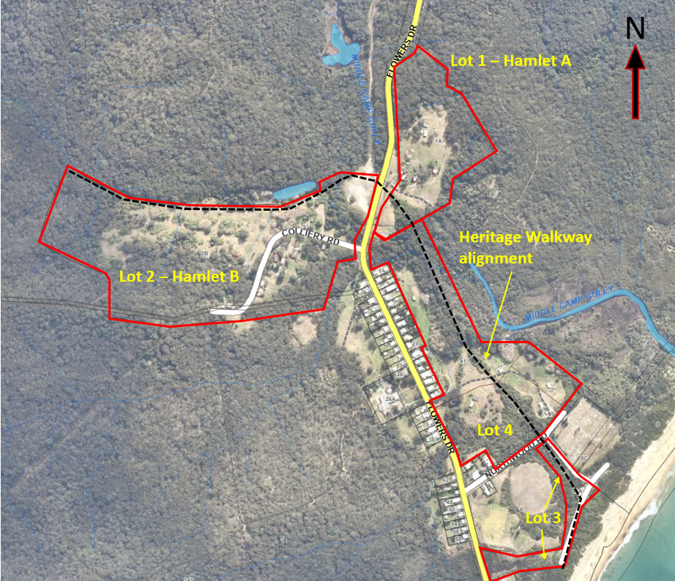

**Figure 2: Location plan of Hamlet A and B, heritage walkway alignment and other land included in application**

1. **THE PROPOSAL AND BACKGROUND** 
   1. **The proposal**

The application seeks consent for the development of a 210-lot residential subdivision in two hamlets, with associated infrastructure and heritage walkway.

Hamlet A will include 50 residential lots, and Hamlet B will include 160 residential lots (refer to figures 3 and 4).

Specifically the development includes:

* site preparation works including earthworks, clearing of vegetation, contamination remediation and removal of subsidence risk associated with shallow mine workings in Hamlet B
* construction of roads, drainage and utility infrastructure
* creation of two privately owned parks (Workshop and Lemon Tree Park)
* landscaping to streets, drainage reserves and public reserves.
* dedication of drainage and public reserve areas to Lake Macquarie Council
* heritage interpretation along the alignment of the heritage walkway and at Workshop and Lemon Tree Parks
* upgrading of intersection of Flowers Drive and Pacific Highway in accordance with the Concept Approval
* construction of a heritage walkway from Hamlet B to the east over Middle Camp Creek and then to the south along the former rail corridor
* provision of contributions and infrastructure in accordance with the approved Staging Plan by the Department of Planning, Industry and Environment (DPIE).

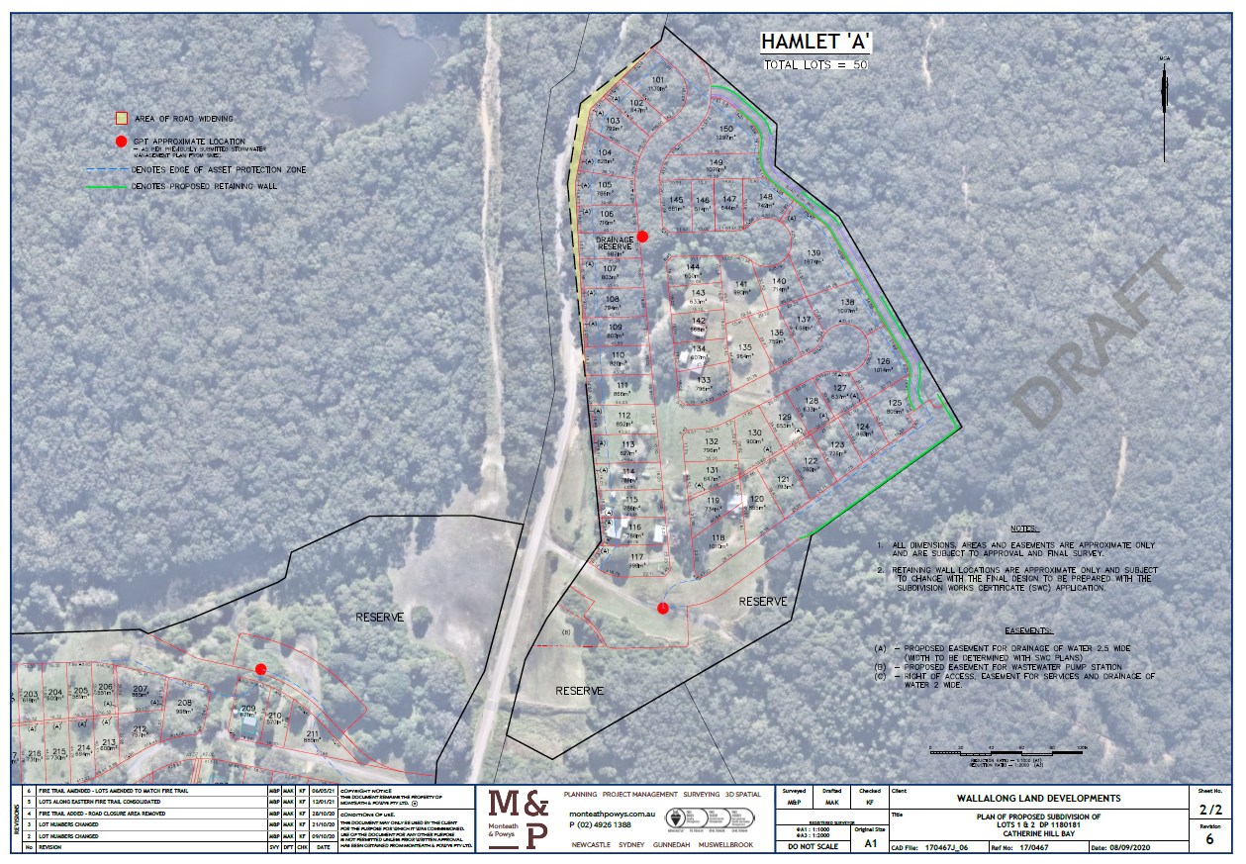

**Figure 3: Hamlet A lot layout**

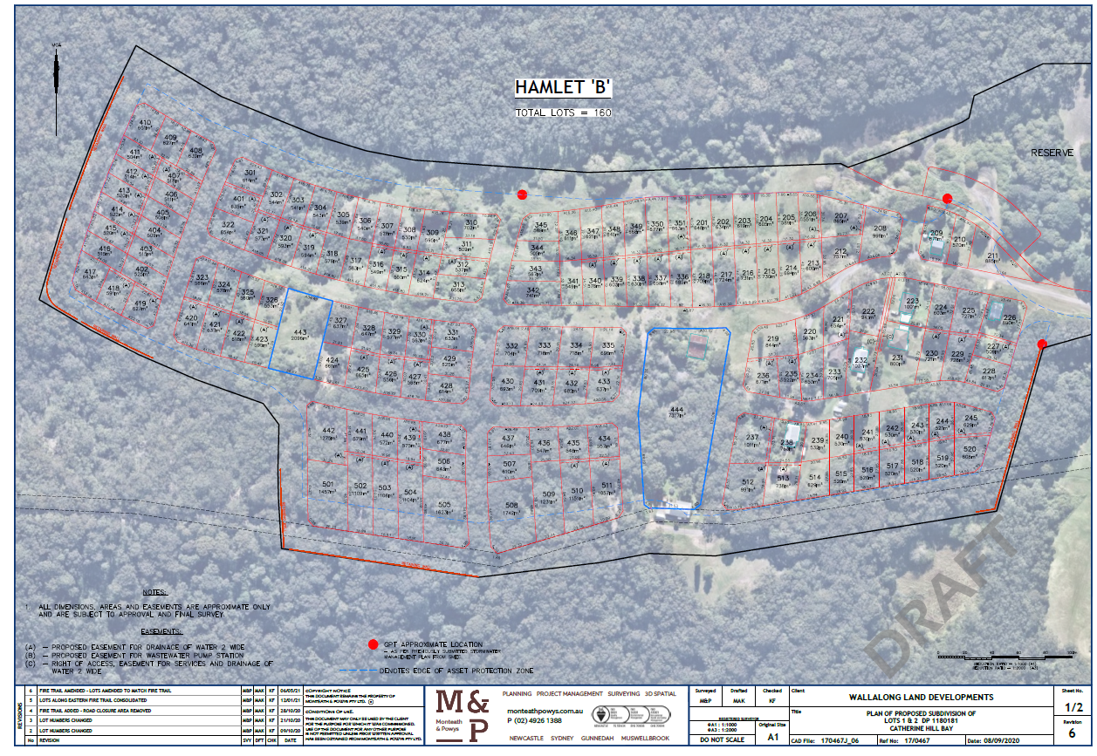

**Figure 4: Hamlet B lot layout**

* 1. **Background of application**

The application was lodged on 24 November 2017. A timetable and key milestones of the application since lodgement is outlined below including the Panel’s involvement with the application.

**Table 1: Timetable and milestones of DA**

|  |  |
| --- | --- |
| **Date** | **Event** |

|  |  |
| --- | --- |
| 24 November 2017 | DA lodged |
| 30 November – 18 December 2017  6 February – 27 February 2020  21 June – 13 July 2021 | Exhibition of the application |
| 30 November 2017  5 October 2021 | Referred to Transport for NSW  Transport for New South Wales response received in accordance with SEPP Infrastructure |
| 19 December 2017  5 November 2020  3 June 2021 | Referred to NSW Rural Fire Service  Referred to NSW RFS  RFS approval received in accordance with condition 1.40 and 1.41 of Concept Approval. |
| 2 April 2020 | Satisfactory Arrangement Certificate from DPIE for state infrastructure contributions |
| 3 June 2020  9 September 2020  14 July 2021 | Panel briefings |
| 28 January 2021 | Staging plan approved by Department of Planning, Industry and Environment. |
| 15 June 2018  8 April 2020  23 July 2021 | Request for information from Council to applicant requesting:   * Urban Release Area Satisfactory Arrangements Certificate * Condition 1.10 – approved modified concept lot layout * Landscape buffer to Flowers Drive * Heritage walkway preliminary civil design * Servicing arrangements * RMS Intersection upgrade details * Details regarding APZs located over landscaped bioretention facilities * Mine Subsidence approval * Road carriageway clarification * Details on land to be dedicated to Council * Changes to lot layout * Impact of earthworks on retained heritage structures * Stormwater design details * Information regarding how Concept Approval Biodiversity conditions had been met * Inclusion of Lemon Tree and Workshop Parks * Visual impact along Flowers Drive (landscape buffer) * Landscaping and Public Domain Plan * Staging Plan * Flood report updated in accordance with ARR 2019 * Details regarding water quality monitoring * Details of VPA * Heritage details (interpretive signage) * Further ecology information * Management arrangements for Workshop and Lemon Tree Parks * Landscaping plans along Flowers Drive * Details regarding heritage walkway * Management plan for mitigating biodiversity impacts at National Park and wetland interface * Heritage impacts due to bulk earthworks * Erosion and sediment control plan * Remediation Action Plan (RAP) * Pothole risk management plan * TfNSW correspondence for intersection upgrade * Expected volume of filling (source) * Identify single storey dwelling lots |
| 18 December 2019  20 February 2020  6 March 2020  9 March 2020  2 April 2020  15 July 2020  10 November 2020  14 December 2020  29 January 2021  24 March 2021  14 May 2021  5 July 2021  17 August 2021 | Amended plans and documentation lodged including:   * Concept Approval compliance table * Amended subdivision plan * Cross section of rail embankment (heritage walkway) * Letter from RMS * Hunter Water formal requirements * Historical aerial photographs * Structural engineers report of Workshop building * Indicative layout plan of stormwater outlets * Cl.34A(3) biodiversity certification letter from Department of Planning and Environment * Wetland boundary verification * Amended indicative staging plan * Revised landscape plan * Bushfire assessment report * Subsidence Advisory approval * Capital Investment Value * Satisfactory Arrangements Certificate * Draft contributions staging plan * Additional ecology information * Heritage Impact Statement further information * Heritage interpretive signage location plan * Revised Statement of Environmental Effects * Revised plan of subdivision * Water/sewer serving strategy * EPBC approval * Amended Concept Approval compliance table * Staging plan * Contribution staging plan * Wetland boundary verification * Heritage response letter * Revised landscape plans * Additional ecological information * VPA * Aboriginal Cultural Heritage Management Plan * Revised bushfire management plan * Revised contribution staging plan * Revised staging plan * Revised plan of subdivision * Approved staging plan * Civil design for Hamlet A to account for bushfire perimeter road/fire trail * Revised bushfire assessment * Retaining wall long section Hamlet A * Revised lot layout * Revised civil design for Hamlet A perimeter laneway * Revised Bushfire Assessment * Revised staging plan * Amended landscape plans * Heritage walkway cross sections * Hamlet A engineering plans * Hamlet B cross sections * Biodiversity response letter * Arboricultural impact report * Preliminary services route plans * Remediation Action Plan * Concept for U Turn Bay at Nords Wharf |
| 5 October 2021 | Referred to Ausgrid |

1. **STATUTORY CONSIDERATIONS**

When determining a development application, the consent authority must take into consideration the matters outlined in Section 4.15(1) of the *Environmental Planning and Assessment Act 1979* (‘EP&A Act’). These matters as are of relevance to the development application include the following:

1. *the provisions of any environmental planning instrument, proposed instrument, development control plan, planning agreement and the regulations*
2. *the likely impacts of that development, including environmental impacts on both the natural and built environments, and social and economic impacts in the locality,*
3. *the suitability of the site for the development,*
4. *any submissions made in accordance with this Act or the regulations,*
5. *the public interest.*

These matters are further considered below.

The development is not integrated development or development requiring concurrence as the terms of the Concept Approval apply.

* 1. **Section 4.15(1)(a)(i) - Provisions of Environmental Planning Instruments**

Under the former provisions of Part 3A (75R), Environmental planning instruments (EPIs) other than State environmental planning policies (SEPPs) do not apply to or in respect of an approved Concept Approval.

The development is also subject to Schedule 2(3B) of the *Environmental Planning and Assessment (Savings, Transitional and Other Provisions) Regulation 2017* whereby any EPI provision that is inconsistent with the Concept Approval has no effect, and any requirement for a master plan under an EPI does not restrict the granting of consent.

The following SEPPs are relevant to this application:

* *State Environmental Planning Policy (State and Regional Development) 2011*
* *State Environmental Planning Policy (Infrastructure) 2007*
* *State Environmental Planning Policy 44 - Koala Habitat Protection*
* *State Environmental Planning Policy No. 55 – Remediation of land*
* *State Environmental Planning Policy 71 - Coastal Protection.*

Ordinarily, the *Lake Macquarie Local Environmental Plan 2014* would apply, however does not as the site and application are benefited by the Concept Approval.

A summary of the key matters for consideration arising from the relevant SEPPs are outlined in **Table 3** and considered in more detail below.

**Table 2: Summary of applicable State Environmental Planning Policies**

|  |  |  |
| --- | --- | --- |
| **EPI** | **Matters for consideration** | **Comply (Y/N)** |

|  |  |  |
| --- | --- | --- |
| State and Regional Development SEPP | * Clause 20 declares the proposal as regionally significant development pursuant to Part 4A of the EP&A Act, clause 3 and 9. | Y |
| Infrastructure SEPP | * Clause 45 – a referral has been sent to Ausgrid and Council are awaiting a response, which is due in November 2021. Upon a response being received, or the 21-day notice period expiring, consent may be granted. * Clause 104(3) - traffic-generating development – subdivision of 200 of more residential lots   Referral sent to Transport for NSW and response provided confirming the proposal is satisfactory with respect to these provisions. | N  Y |
| SEPP 44 – Koala Habitat Protection | * Part 2 (clauses 6 – 10) of the SEPP applies as land is greater than one hectare and an assessment must be made as to whether the land is potential or core koala habitat.   Land was determined to not be core Koala habitat. | Y |
| SEPP 55 – Remediation of land | * Clause 7 – a Remedial Action Plan has been submitted, which does not conclusively determine the site is suitable for the proposed residential use. | N |
| SEPP 71 – Coastal Protection | * Clause 4 declares the policy applies to land in the Coastal Zone.   The site is in the Coastal Zone   * Clause 8 and clauses 14-16 outlines matters to be assessed when determining an application for development.   The proposal achieves appropriate outcomes that are consistent with the SEPP.   * Clause 18 – specifies a masterplan must be adopted for subdivision in a sensitive coastal location and more than 25 lots.   The development is subject to the *Environmental Planning and Assessment (Savings, Transitional and Other Provisions) Regulation 2017* whereby any requirement for a master plan under an EPI does not restrict the granting of consent. | Y |

**State Environmental Planning Policy (State and Regional Development) 2011**

The proposal is identified as regionally significant development under Part 4 Regionally significant development and Schedule 4A of the *EP&A Act* as the development has a CIV over $20 million (cl.3), and is coastal subdivision (cl.9).

The Hunter and Central Coast Regional Planning Panel will be the consent authority for the application.

**State Environmental Planning Policy (Infrastructure) 2007**

The development is traffic generating development under clause 104 and Schedule 3 of the SEPP as the application proposes more than 200 residential lots.

The application was referred to Transport for NSW (TfNSW) who confirmed the proposal is satisfactory with respect to the SEPP, and acknowledged upgrading of the intersection of Flowers Drive and the Pacific Highway will address potential traffic impacts arising from the development.

Consideration has also been given to the accessibility of the site, and potential traffic safety, road congestion and parking implications of the development. The development will provide suitable internal roads and safe intersections to Flowers Drive. Parking will be available within carriageways and on the lots with future housing. Council is satisfied the proposal achieves these provisions of the SEPP.

**State Environmental Planning Policy 44 – Koala Habitat Protection**

Part 2 (clauses 6 – 10) of the SEPP applies as land is greater than one hectare and an assessment must be made as to whether the land is potential or core koala habitat.

Land was determined to be potential Koala habitat but not core Koala habitat.

**State Environmental Planning Policy No. 55 – Remediation of Land**

Clause 7 of the SEPP requires the consent authority to consider whether the land is contaminated, and if the land is contaminated, it is satisfied the land is suitable in its contaminated state (or will be suitable, after remediation) for the purpose for which the development is proposed to be carried out.

A Remedial Action Plan (RAP) has been submitted with the application, which identified the land is contaminated with metals, hydrocarbons and asbestos. The RAP identifies mitigation strategies but also identifies further assessment is required to conclusively determine the site is suitable for the proposed residential use.

Council’s Environmental Officer is not satisfied the site can be made suitable for the use of the site based on the information provided. The officer recommends the further assessments are undertaken and submitted for further consideration, or the RAP is reviewed by a NSW EPA Accredited Site Auditor to assess whether the site is suitable for residential use and can meet the provisions of the SEPP.

Council recommend the determination of the application be deferred pending the satisfactory resolution of either of the above options. Should the Panel not support this, the application must be refused.

**State Environmental Planning Policy 71 – Coastal Protection**

The site is identified within the Coastal Zone and the SEPP applies.

Clause 8 and clauses 14-16 outlines matters to be assessed when determining an application for development including public access to the foreshore, impacts to the coastal foreshore including visual impacts, preservation of Aboriginal and European heritage, and stormwater management.

The proposal is consistent with the SEPP in that it provides a new opportunity for public access to the coast via the heritage walkway, appropriately manages impacts to the coastal foreshore through design and siting and environmental management measures, protects and preserves Aboriginal and European heritage, and provides appropriate stormwater management.

Clause 18 specifies a masterplan must be adopted for subdivision in a sensitive coastal location and more than 25 lots. The development is subject to the *Environmental Planning and Assessment (Savings, Transitional and Other Provisions) Regulation 2017* whereby any requirement for a master plan under an EPI does not restrict the granting of consent.

* 1. **Section 4.15 (1)(a)(ii) - Provisions of any proposed instruments**

There are several proposed instruments which have been the subject of public consultation under the EP&A Act, and which are relevant to the proposal. These proposed instruments are considered below.

* *State Environmental Planning Policy (State and Regional Development) 2011*

During the assessment period of the application, several versions of the SEPP were exhibited and adopted. Relevant changes made to the SEPP related to legislative references changes in March 2018, however there is no material impact to the assessment.

* *State Environmental Planning Policy (Infrastructure) 2007*

During the assessment period of the application, several versions of the SEPP were exhibited and adopted. Relevant changes made to the SEPP related to refences to RMS and TfNSW, however there is no material impact to the assessment.

* *State Environmental Planning Policy 44 – Koala Habitat Protection*

During the assessment period of the application the SEPP was repealed on 29 February 2020. No changes occurred to the SEPP prior to its repeal.

* *State Environmental Planning Policy (Koala Habitat Protection) 2019, 2020 and 2021*

During the assessment period of the application, SEPP (Koala) 2019 was introduced and repealed. The 2020 and 2021 versions of the SEPP remain in force.

The application has established the site is not core koala habitat, and therefore remains consistent with the SEPPs.

* State Environmental Planning Policy No. 55 – Remediation of Land

During the assessment period of the application, several versions of the SEPP were exhibited and adopted and there were no changes that have an impact to the assessment.

* *Draft SEPP Coastal Management 2018*

During the assessment period of the application, the SEPP came into force in March 2018 and repealed SEPP 71. The Coastal Management SEPP remains in force.

Under the SEPP the development is located within land mapped as coastal wetlands and buffer, coastal environmental area and coastal use area.

Impact of the development to adjacent wetlands has been incorporated into the Concept Approval (refer to Attachment B). Council’s Flora and Fauna Planner (Ecologist) has reviewed the proposal and is satisfied the proposal will not adversely impact upon the ecological function of the wetlands.

The proposal is consistent with the SEPP in that it provides a new opportunity for public access to the coast via the heritage walkway, appropriately manages impacts to the coastal foreshore through design and siting and environmental management measures, protects and preserves Aboriginal and European heritage, and provides appropriate stormwater management.

* *Remediation of Land SEPP*

An Explanation of Intended Effect (EIE) was exhibited from 31 January to 13 April 2018.

The draft SEPP maintains consistent principles in identifying if land is contaminated, and if the land is contaminated, consent authorities being satisfied the land is suitable in its contaminated state (or will be suitable, after remediation) for the purpose for which the development is proposed to be carried out.

The draft SEPP does not materially impact the assessment of the application.

* *Draft Environment SEPP*

An EIE was exhibited from 31 October to 31 January 2018.

The site is not located within any of the key catchments, and is not urban bushland and the draft SEPP is not relevant to the application.

* *Draft Design and Place SEPP*

An EIE was exhibited from 26 February 2021 to 28 April 2021.

The draft SEPP captures certain subdivision development as ‘precinct development’ or ‘significant development’, and introduces the Design Review Guide (DRG).

The draft SEPP and DRG have not been exhibited and it is unclear whether the application would be captured as precinct or significant development.

It is considered the current application is consistent with the principles of the draft SEPP as it provides residential subdivision with specific character through the Concept Approval design guidelines, understanding and integration of Place and Country, creates inviting public spaces and connectivity through the heritage walkway, and balances environmental aspects with appropriate development outcomes.

* *Draft Environmental Planning and Assessment Regulation 2022*

None of the proposed changes to the Regulation have an impact to the assessment.

* 1. **Section 4.15(1)(a)(iii) - Provisions of any Development Control Plan**

Ordinarily, the *Lake Macquarie Development Control Plan 2014 (LM DCP 2014)* would apply, however does not as the site and application are benefited by the Concept Approval.

Condition 1.11 of the Concept Approval requires adoption of revised urban design guidelines (UDG) prior to the first application for subdivision. These revised guidelines were approved by Planning and Infrastructure in 2013 and are to be used to consider the merits of the proposed development. An assessment of the development against the UDG is included in Appendix C.

A summary of the key matters for consideration arising from the UDG are outlined in **Table 4**.

**Table 4: Summary of UDG controls**

|  |  |  |
| --- | --- | --- |
| **Control** | **Consideration** | **Comply (Y/N)** |

|  |  |  |
| --- | --- | --- |
| Street types | The proposed street typology is generally consistent with the UDG. | Y |
| Parks and open space | The application proposes to create four parks, as specified in the UDG. Satisfactory details have been provided for two of the parks, however not the remaining two.  Council recommend further details are provided for these parks prior to determination. Alternatively, conditions can be imposed requiring detailed landscaping plans be provided for these parks with the respective Subdivision Works Certificate.  The proposed landscape buffer zone to Flowers Drive is generally consistent with the UDG.  Alignment details have been provided for the heritage shared pathway, however detailed design plans have not been provided. Council recommend further details are provided prior to determination. Alternatively, conditions can be imposed requiring detailed design plans be provided for these parks with the respective Subdivision Works Certificate. | N  Y  N |
| Plant types and materials | The proposed planting types and materials is generally consistent with the UDG. | Y |
| Building types | The proposed lot sizes are generally consistent with the UDG. | Y |
| Asset protection zones | The proposed APZs are generally consistent with the UDG. | Y |

* 1. **Section 4.15(1)(a)(iiia) – Planning agreements under Section 7.4 of the EP&A Act**

A planning agreement was entered into under Section 93F (now Section 7.4) of the EP&A Act by the former owners of the land, Coal and Allied, and the State in March 2012.

The planning agreement provides for:

* the payment of emergency service contributions to the State upon development of the land
* upgrading of the Flowers Drive and Pacific Highway intersection prior to the creation of the first urban lot
* transfer of environmental offset land to the Environment Minister and improvement of this land in regard to erosion, weeds and rehabilitation.

A Deed of Amendment to the planning agreement was entered into with the Minister for Planning and the Minister for National Parks in April 2020 which transfers the obligations of the former owner of the land to the current owner.

The proposal is consistent with this planning agreement.

* 1. **Section 4.15(1)(a)(iv) - Provisions of Regulations**

The application proposes demolition of structures within the site. Conditions of consent will be imposed requiring demolition works to be undertaken in accordance with the relevant Australian Standard.

* 1. **Section 4.15(1)(b) - Likely impacts of development**

The likely impacts of the development, including environmental impacts on both the natural and built environments, and social and economic impacts have been considered as outlined above and the key issues section below.

The assessment of this matter is inconclusive until the outstanding issues identified in this report have been addressed.

* 1. **Section 4.15(1)(c) - Suitability of the site**

The application provides a development that is consistent with the Concept Approval applying to the land and has demonstrated compliance with the urban design guidelines. The proposal is considered to fit the locality and be suitable for the site.

* 1. **Section 4.15(1)(d) - Public submissions**

These submissions are considered in Section 5 of this report.

* 1. **Section 4.15(1)(e) - Public interest**

The assessment of this matter is inconclusive until the outstanding issues identified in this report have been addressed.

1. **REFERRALS AND SUBMISSIONS** 
   1. **Agency Referrals and Concurrence**

The development does not require concurrence and is not integrated development as the terms of the Concept Approval apply.

The Concept Approval requires the following requirements to be met:

* Condition 1.14 – DPIE – requirement for staging plan to be approved.
* Condition 1.16 – OEH – requirement for management measures for interface impacts with the adjacent National Park to be prepared in consultation with OEH.
* Condition 1.36 – TfNSW – requirement to upgrade the intersection of Flowers Drive with the Pacific Highway.
* Condition 1.41 - NSW RFS – requirement for a bushfire management plan to the satisfaction of the RFS.
* Condition 1.45 and 1.46 - Subsidence Advisory NSW – requirement for mine subsidence / pothole risk assessment.

The application has been referred to various agencies as outlined below in Table 5.

**Table 5: Referrals to agencies**

|  |  |  |  |
| --- | --- | --- | --- |
| **Agency** | **Referral trigger** | **Comments** | **Resolved** |

|  |  |  |  |
| --- | --- | --- | --- |
| Department of Planning, Industry and Environment. | Condition 1.14 of Concept Approval | The Staging Plan was approved by DPIE in January 2021 which addresses the requirements of the Concept Approval, including specifications of the heritage pathway. | Y |
| Environment Agency Head (Environment, Energy & Science Group within DPIE)  (OEH) | Condition 1.16 of Concept Approval | The management of the interface between the development area and conservation lands has not been referred to or endorsed by OEH.  Council recommend further details are provided and these details be referred to OEH.  Alternatively, conditions can be imposed requiring detailed plans be provided and approved by OEH with the respective Subdivision Works Certificate. | N |
| TfNSW | Condition 1.36 of Concept Approval | The application was referred to TfNSW who confirmed the proposal is satisfactory with respect to the SEPP, and acknowledged upgrading of the intersection of Flowers Drive and the Pacific Highway will address potential traffic impacts arising from the development. | Y |
| Clause 104 – Infrastructure SEPP – traffic generating development | The application was referred to Transport for NSW (TfNSW) who confirmed the proposal is satisfactory with respect to the SEPP, and acknowledged upgrading of the intersection of Flowers Drive and the Pacific Highway will address potential traffic impacts arising from the development. | Y |
| NSW RFS | Condition 1.41 of Concept Approval | A bushfire management plan has been submitted and approved by the RFS which includes locations of APZs, vegetation standards, access arrangements and building areas on lots. | Y |
| SA NSW | Condition 1.45 of Concept Approval | The application was referred to Subsidence Advisory NSW (SA NSW) who have issued their approval to the development subject conditions | Y |
| Condition 1.46 of Concept Approval |
| Ausgrid | Cl 45 – Infrastructure SEPP  Development near electrical infrastructure | The application has been referred to Ausgrid and Council are awaiting a response, which is due in November 2021.  Upon a response being received, or the 21-day notice period expiring, consent may be granted. | N |

* 1. **Council referrals**

The development application has been referred to various Council officers for technical review as outlined **Table 6.**

**Table 6: Consideration of Council referrals**

|  |  |  |
| --- | --- | --- |
| **Officer** | **Comments** | **Resolved** |

|  |  |  |
| --- | --- | --- |
| Ecology | Council’s Ecologist is supportive of the application subject to conditions of consent relating to the preservation and protection of any trees that are to be retained, the preparation and implementation of a Vegetation and Fauna Management Plan and measures to be utilised when removing any hollow bearing trees from the site.  The officer considers impacts to flora and fauna have been appropriately assessed and mitigated by achieving approval under S34A of the *Biodiversity Conservation (Savings and Transitional) Regulation 2017*, with the proposed works reflective of the existing Concept Approval and Planning Agreement and there are no significant impacts to any new species listed after the S34A certification.  The officer also notes the proposed water and sewer infrastructure will occur within areas already cleared and slashed, and therefore will not have significant impact to flora and fauna. | Y |
| Landscape Architect  (visual impact and landscaping) | Council’s Landscape Architect is supportive of the application subject to conditions of consent relating to plant species, and details required to be shown on landscape plans to be submitted with a Subdivision Works Certificate. A condition has been included requiring some species to be changed from those shown on the submitted plans, due to more appropriate / endemic species being available.  The officer is supportive of the proposed planting along Flowers Drive and considers the landscaping outcomes satisfactory to screen the development and minimise visual impact of the development. | Y |
| Environmental Management  (contamination, acoustic impact, sewer and water) | Council’s Environmental Management Officer is not supportive of the application as submitted to date, as insufficient contamination investigation has occurred to determine whether the remediation action plan is suitable, and whether the site is suitable for its intended use.  The officer recommends further assessment is undertaken as recommended in the submitted RAP, or a NSW EPA Accredited Site Auditor provides a statement the RAP is adequate for the site.  The issue is considered further in the key issues section of this report. | N |
| Traffic Engineers | Council’s Traffic Engineer is satisfied with the proposal. The officer has recommended an additional speed hump is installed adjacent to Hamlet A to further supplement the existing traffic calming measures through Middle Camp. | Y |
| Tree | Council’s Tree Assessment Officer has reviewed the application and the Arboricultural Impact Evaluation Report submitted, and is supportive of the application  The proposed minimum offset of 2.5 metres is generally considered satisfactory to not impact the structural root zone of trees on the boundary of the site. The officer supports recommendation to carry out individual arboricultural assessments at detailed design phase for trees within proximity to boundary and implement appropriate construction techniques to retain these trees. Condition of consents are recommended to support this outcome. | Y |
| Heritage | Council’s Heritage Officer is supportive of the application subject to conditions of consent relating to the provision a satisfactory heritage archival and photographic recording of the E Pitt area, an Archaeological Management Plan for construction activities, and satisfactory detailed construction drawings for any heritage interpretation items. | Y |

* 1. **Community consultation**

The proposal was notified in accordance with the Council’s *LMDCP 2014* and Council’s Community Participation Plan on the following three occasions:

* 30 November – 18 December 2017
* 6 February – 27 February 2020
* 21 June – 13 July 2021

The notification included letters sent to 41 adjoining and adjacent properties.

A total of four unique submissions, all in objection to the proposal were received. The issues raised in these submissions are considered in **Table 7.**

**Table 7: Community submissions**

|  |  |  |
| --- | --- | --- |
| **Issue** | **No of submissions** | **Council comments** |

|  |  |  |
| --- | --- | --- |
| Increased traffic in Catherine Hill Bay village | 3 | This matter was similarly raised and considered for the Concept Approval.  To address concerns Condition 1.38 was included in the final Concept Approval and requires a Local Area Traffic Management Scheme (LATM) to be prepared and implemented.  A LATM scheme has been considered and implemented by Council in 2017 which includes linemarking and seven speed management devices installed in Flowers Drive.  The applicant has proposed to supplement this existing scheme with one additional speed management device adjacent to Hamlet A. |
| Traffic safety at intersection of Flowers Drive and Pacific Highway | 3 | This matter was considered for the Concept Approval.  Condition 1.36 was included in the final Concept Approval and requires the intersection at the Pacific Highway and Flowers Drive to be upgraded to the satisfaction of TfNSW prior to the delivery of the first residential lot.  The current application addresses these upgrading works, and Council consider the proposal to achieve satisfactory traffic safety outcomes. |
| Stormwater management | 1 | Conditions 1.20 – 1.24 of the Concept Approval require the management of stormwater impacts from the development.  A suitable stormwater management plan has been submitted with the development application and includes gross pollutant traps and biofiltration basins to address the potential water quality impacts of the development, and capture and control discharge of stormwater to the watercourse in the southern portion of the site.  Stormwater modelling has been submitted to demonstrate the proposed stormwater management chain, including discharge to watercourse, will not have negative impacts on downstream properties in peak storm events.  A water quality and hydrological monitoring will be implemented to ensure the development does not adversely impact the adjacent wetland or Swamp Mahogany Paperbark Forest. The stormwater management report provides a suitable monitoring plan that will provide quarterly results to Council and NSW Office of Water from six months prior to the commencement of construction activities, until two years after the commissioning of the water quality facilities. |
| Ecology impacts due to clearing | 2 | This matter was considered for the Concept Approval where OEH were satisfied the conservations lands that were dedicated under a planning agreement adequately offset the impacts of the proposed development.  Condition 1.16 of the Concept Approval requires strategies to be in place prior to the commencement of works to managed construction impacts from the development. |
| Utility provision | 2 | Middle Camp Village is currently not serviced with reticulated water and sewer.  A water and sewer servicing strategy has been approved by Hunter Water Corporation (HWC) which provides both reticulated water and sewer services to the site. Servicing will be from Nords Wharf, across the Pacific Highway and along the road reserve of Flowers Drive.  As part of the development, a future connection point for the Middle Camp village will be provided.  Electrical servicing will be through an existing cleared easement through the National Park. There will be no impacts to the existing electrical service as a result of this development. |
| Impacts to the heritage value of the existing village | 1 | As required by Condition 1.11 of the Concept Approval, revised urban design guidelines have been adopted for the site and future dwellings which account for the heritage values of the locality and site, as well as landscaping and building height outcomes to ensure the heritage values of the existing village are not impacted.  The proposed development is consistent with the UDG. |
| Aboriginal Heritage | 1 | An Aboriginal heritage management plan has been provided with the application and identifies there are no aboriginal heritage items or areas of significance within the site.  Precautionary conditions of consent will be applied to ensure any unexpected finds are managed appropriately. |
| Confirmation of the Statement of Commitments | 1 | A staging plan in accordance with Condition 1.14 of the Concept Approval has been approved by DPIE. This Staging Plan outlines the timing for and provision of infrastructure, scholarships and the payment of local and state contributions in accordance with the Statement of Commitments that form Appendix 1 of the Concept Approval.  Any consent issued will require the terms of the Staging Plan are adhered to. |
| Visual impacts | 2 | Condition 1.9 of the Concept Approval required a detailed visual assessment to be undertaken for the development, and submitted to DPIE for inclusion in the revised urban design guidelines.  These revised guidelines were approved by Planning and Infrastructure in 2013 and include controls to ensure the visual impact of development is appropriate.  The proposed development is consistent with the UDG. An assessment of the development against the UDG is included in Appendix C. |

1. **KEY ISSUES**

The following key issues are relevant to the assessment of the application having considered the relevant planning controls and the proposal in detail.

**5.1 Concept Approval**

The development is generally consistent with the terms of the approved Concept Plan, with the exception of the following:

* Endorsement from Office of Environment and Heritage regarding management of the interface between the development area and the adjacent National Park
* Outcome of Workshop Building retention or demolition
* Extent of earthworks, ground water impacts and impacts to retention of heritage structures
* Remediation of contamination
* Detailed design for heritage pathway
* Landscaping details for Workshop Park and Lemon Tree Park.

Details of the assessment of the Concept Approval are included in Attachment B.

**5.2 Contamination**

Clause 7 of SEPP 55 requires the consent authority to consider whether the land is contaminated, and if the land is contaminated, it is satisfied the land is suitable in its contaminated state (or will be suitable, after remediation) for the purpose for which the development is proposed to be carried out.

A Remedial Action Plan (RAP) has been submitted with the application, which identified the land is contaminated with metals, hydrocarbons and asbestos. The RAP identifies mitigation strategies but also identifies further assessment is required to conclusively determine the site is suitable for the proposed residential use.

Council’s Environmental Officer is not satisfied the site can be made suitable for the use of the site based on the information provided. The officer recommends the further assessments are undertaken and submitted for further consideration, or the RAP is reviewed by a NSW EPA Accredited Site Auditor to assess whether the site is suitable for residential use and can meet the provisions of the SEPP.

Council recommend the determination of the application be deferred pending the satisfactory resolution of either of the above options. Should the Panel not support this, the application must be refused.

**5.3 Biodiversity offsets**

The Concept Approval consented to the development of 28 hectares of land (including 13.14 hectares of clearing of native and exotic vegetation) and required the dedication of 525 hectares of environmentally significant conservation lands.

The dedication of the conservation lands to the State Government occurred in early 2013 with the land currently managed by the National Parks and Wildlife Service.

DPIE have provided certification under clause 34A(3) of the *Biodiversity Conservation (Savings and Transitional) Regulation 2017* that certifies the development has appropriately considered and mitigated biodiversity impacts associated with the development.

* 1. **Bushfire protection**

Condition 1.41 requires a bushfire management plan to be submitted with the subdivision application and be to the satisfaction of the NSW RFS.

Following amendment to the design of the perimeter road to the east of Hamlet A to be a narrower rear lane that still catered for fire fighting vehicles, and minimised the extent of cut and fill works along the site perimeter, the RFS were supportive of the bushfire management plan, which includes locations of APZs within the site only, vegetation standards, access arrangements and building areas on lots.

* 1. **Visual impacts**

Condition 1.9 of the Concept Approval required a detailed visual assessment to be undertaken for the development, and submitted to DPIE for inclusion in the revised urban design guidelines. The most significant outcomes of the revised guidelines include landscaping requirements to screen Hamlet A, and restriction of dwellings to one story in the southern portion on Hamlet B.

The proposed development is consistent with the UDG regarding landscaping outcomes, and restrictions will be placed on the title of relevant lots to limit future building form to single storey only.

A detailed assessment of the development against the UDG is included in Appendix C.

* 1. **Traffic impacts**

Condition 1.36 of the Concept Approval requires the intersection at Flowers Drive and Pacific Highway to be upgraded to address traffic impacts associated with the development.

The application was referred to TfNSW for consideration of traffic impacts under clause 104 and Schedule 3 of the Infrastructure SEPP.

TfNSW are satisfied with the proposal and acknowledge upgrading of the intersection of Flowers Drive and the Pacific Highway, as required by the Concept Approval will address potential traffic impacts arising from the development.

Consideration has also been given to the accessibility of the site, and potential traffic safety, road congestion and parking implications of the development. The development will provide suitable internal roads and safe intersections to Flowers Drive. Parking will be available within carriageways and on the lots with future housing.

* 1. **Ecological impacts – impacts on vegetation due to servicing and intersection works**

A water and sewer servicing strategy has been approved by HWC which provides both reticulated water and sewer services to the site. Servicing will be from Nords Wharf, across the Pacific Highway and along the road reserve of Flowers Drive.

Middle Camp Village is currently not serviced with reticulated water and sewer. As part of the development, a future connection point for the Middle Camp village will be provided.

The applicant has provided an alignment for the provision of water and sewer trenching, which is primarily already cleared or disturbed. An assessment of this alignment has been undertaken and there will not be a significant impact to vegetation.

Electrical power to the existing Middle Camp Village is via an existing cleared easement adjacent to Flowers Drive, and connects to the Pacific Highway. This easement is proposed to be utilised for the development.

The intersection works at the Pacific Highway will be contained within the existing area of pavement and as such will not require the clearing of any additional vegetation.

* 1. **Workshop Building**

Condition 1.32 of the Concept Approval requires a detailed heritage assessment of the workshop building and archaeological remains of the house to be prepared for any subdivision application for Hamlet B. The assessment is to investigate heritage significance, opportunities for adaptive re-use, recommendation for removal or retention, and ongoing management provisions (if retained).

A development application for demolition of the Workshop Building is currently being assessment by Council (DA/2246/2021). This application does not include subdivision, and therefore sits outside of, and does not benefit from the Concept Approval. The outcome of this application will inform the satisfaction of the Concept Approval condition.

* 1. **Workshop and Lemon Tree Parks**

Condition 1.8 of the Concept Approval requires that if the Workshop and Lemon Tree parks are to be retained, then management arrangements for these parks are required.

The application previously proposed to remove Workshop and Lemon Tree Parks which would have triggered a requirement to modify the Concept Approval.

The application has been revised and proposes to maintain the Workshop and Lemon Tree parks. A plan of management will be provided prior to the release of the Subdivision Certificate that creates these lots. The timing of this outcome forms part of the Staging Plan approved by DPIE.

* 1. **European heritage and heritage walkway**

The Concept Approval and urban design guidelines provide for the construction of a heritage walkway. The application proposes construction of the heritage walkway from Hamlet B to the east over Middle Camp Creek and then to the south along the former rail corridor.

An assessment of the heritage impact of the heritage pathway on the Catherine Hill Bay Colliery Railway has been submitted. Council’s Heritage Planner has reviewed and is satisfied with the documentation.

Satisfactory landscaping details have been provided, however detailed design plans of the walkway have not been provided. Council recommend further details are provided prior to determination. Alternatively, conditions can be imposed requiring detailed design plans be provided for these parks with the respective Subdivision Works Certificate.

The Concept Approval also requires assessment and retention of heritage items within the development footprint. Revised earthworks plans and details are required to be submitted which address changes to the lot layout and proposed remediation and grouting works to enable assessment of the impact of these works to be undertaken.

**5.11 Stormwater management**

Conditions 1.20 – 1.24 of the Concept Approval require the management of stormwater impacts from the development.

A suitable stormwater management plan has been submitted with the development application and includes gross pollutant traps and biofiltration basins to address the potential water quality impacts of the development, and capture and control discharge of stormwater to the watercourse in the southern portion of the site.

Stormwater modelling has been submitted to demonstrate the proposed stormwater management chain, including discharge to watercourse, will not have negative impacts on downstream properties in peak storm events.

A water quality and hydrological monitoring will be implemented to ensure the development does not adversely impact the adjacent wetland or Swamp Mahogany Paperbark Forest. The stormwater management report provides a suitable monitoring plan that will provide quarterly results to Council and NSW Office of Water from six months prior to the commencement of construction activities, until two years after the commissioning of the water quality facilities.

**5.12 Impacts to adjacent National Park**

The development proposes cut or fill, with associated retaining adjacent to the interface of the site with the National Park.

The most extensive area is along the western and southern boundary of Hamlet B, and the north-western boundary of Hamlet A (refer to Engineering Plans).

The lot layout for Hamlet B has been modified to provide an extra wide road reserve in excess of 21 metres along these interfaces. This will ensure a minimum 8.5 metre nature strip is available between the carriageway and the National Park boundary to account for retaining walls not impacting to vegetation within the National Park.

The perimeter road required by the RFS for Hamlet A has also been modified (with approval from the RFS) to be one-way only to ensure retaining walls do not impact the vegetation within the National Park.

Conditions of consent will also be imposed restricting any excavation within three metres of the National Park boundary.

1. **CONCLUSION**

This development application has been considered in accordance with the requirements of the EP&A Act and the Regulations as outlined in this report.

Following a thorough assessment of the relevant planning controls, issues raised in submissions and the key issues identified in this report, it is considered that the application can be supported following resolution of the outstanding matters identified in this report.

1. **RECOMMENDATION**

Development application DA/2238/2017 for subdivision of two lots into 210 residential lots, associated infrastructure and heritage walkway at 1A, 2B, 41 and 69A Flowers Drive, Catherine Hill Bay be approved, following resolution of outstanding matters, subject to the draft conditions of consent, and any additional conditions required following resolution of outstanding matters (refer to Attachment A).

Should the Panel not support resolution of the outstanding matters, the application must be refused. Refusal of the application would also result in the Concept Approval lapsing.